
PinJig Orientation Rules –
Structural Manufacturing

PinJig Orientation Rules.doc
Status: Draft
Author: StructMfg-Team

SM3D Concept Design Document.
December 8 , 2011
© 2011 Intergraph Corporation. All rights reserved.
The content of this document is proprietary work of Intergraph Corporation, or relevant third parties, and is protected by copyright law and international treaty. Any use, duplication, distribution or disclosure of such, other than as specified herein, is unauthorized and in violation of applicable copyright law and international treaty. All rights in content or materials bearing copyright notice or other attribution of third party rights are reserved to the relevant third party. United States Government license rights are limited to those mandatory rights identified in DFARS 252.227-7015(b).
Intergraph may make improvements and/or changes in the products and/or the programs described in this publication at any time without notice.
Any content or materials supplied hereunder are provided "as is," without warranty of any kind, either expressed or implied, including, but not limited to, any implied warranties of merchantability, fitness for a particular purpose, or against infringement. In no event shall Intergraph be liable for any damages arising out of, or in connection with the downloading, viewing, use, duplication, distribution or disclosure of any content or material published by Intergraph, including but not limited to any direct, indirect, incidental, special, punitive or consequential damages, or loss or corruption of data.
Some jurisdictions do not allow the exclusions or limitations set forth above, so the above may not apply to you. The exclusions or limitations shall apply in all jurisdictions to the maximum extent allowed by law.

Intergraph Corporation
170 Graphics Drive
Madison, AL 35758
Phone: +1.256.730.2000
Toll Free USA: +1.800.345.4856
Fax: +256.730.2048

Contents
Introduction 2
References 2
Definitions 2
Requirements 3
Bulkload 4
Rule Framework and Implementation 5

Revision # | Date Revised | Revised By | Description
0.1 | 08- Dec- 2011 | Manasa Jaisetty | Initial Version.

Introduction
The purpose of this document is to describe the framework of PinJig orientation rule. This rule supports the following:
- Customization of balance computation
- Customization of pin alignment

References

CR-CP-197055 | Mfg Jig 1.2 new Rotate Method by 2 corners on parallel_review R1.docx
CR-CP-197054 | Mfg Jig 1 1 new Balance Method_Review R1.docx

Definitions

Requirements
New Balance Options:
The reqirement is to support new balance method options for the user to define the pin jig base plane through GUI and provide rule framework to customize the behavior. The new options are categorized as below:
- Plane by Average of Corners: It is an average plane created from four corners of the supported plates.
- Plane by Three Corners: It is a plane created from three corners of the supported plates.
- Plane by Points: It is an average plane created from four points on the supported plates. The points can be the corners of the supported plates, end points of the seams, knuckles, reference curves, user defined marking lines.
- Plane by Reference Line: It is a plane created from end points of the reference line and one/two plate corners. The reference line can be seam, knuckle, reference curve, user defined marking line.
New Pin Alignment Options:
The requirement is to expose the various pin alignment options to the user through GUI and support customization. Following are the options:
- Default – Align pin bed to the tightest box bounding the supported plates
- Longest Edge - Pins are aligned based on the longest contour. The rows or columns of pins are parallel to the line joining the end points of the longest contour
- Global - Pins are aligned based on the global coordinate system. The rows or columns of pins are parallel to the global axes
- Pins On CenterLine - Pins are aligned based on the centerline. A row of pins is placed on the centerline. This option is only available when the selected plates cross the centerline of the hull.

Bulkload
- “StrMfgPinJigAlignmentTypes” is the codelist in “AllStructMfgCodeLists.xls” workbook for pin alignment types. Users can add new alignment types to this sheet. Need to put “A” in place of “!” in front of the alignment type.
Location: “\ShipCatalogData\BulkLoad\DataFiles\StructManufacturing\AllStructMfgCodeLists.xls”
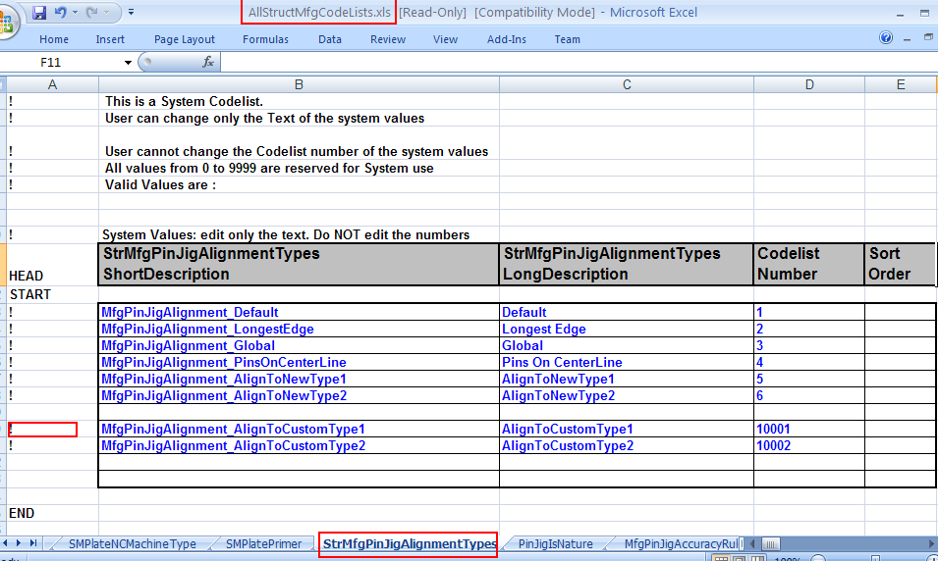

- Exposed “PinJigIsNature” sheet in “AllStructMfgCodeLists.xls” workbook. User can further customize by adding new balance options to this sheet. Need to put “A” in place of “!” before the balance option.
Location: “\ShipCatalogData\BulkLoad\DataFiles\StructManufacturing\AllStructMfgCodeLists.xls”
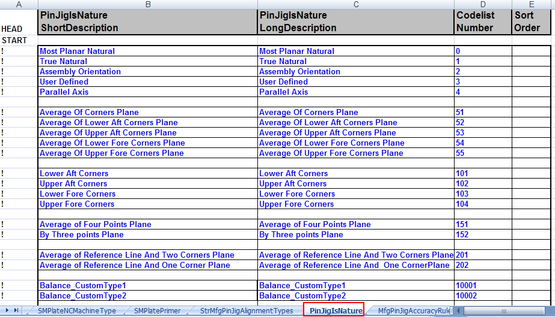
- “MfgPinJigRules” sheet(RuleType = 413) has the rules to support customization of the balance computation and pin alignment. User can modify the ProgID of the existing rule or add new rule by bulkloading in AMD mode (Need to put “A” in place of “!’ in front of the rule name).
Location: “\ShipCatalogData\BulkLoad\DataFiles\StructManufacturing\StructMfgSettings.xls”
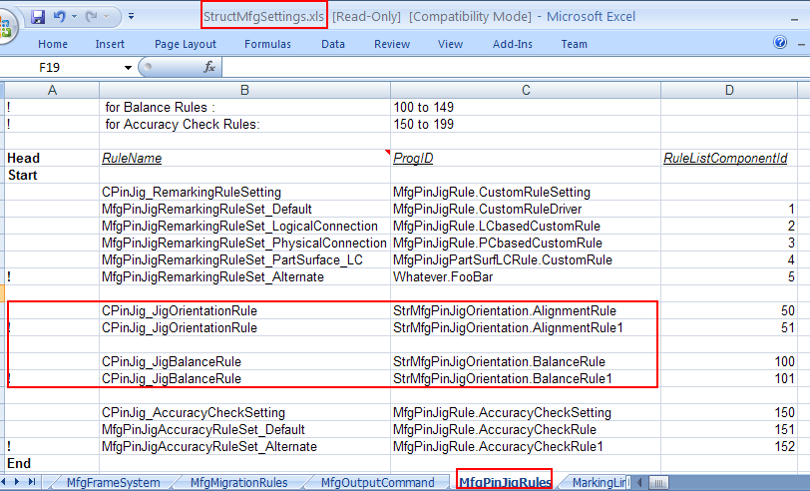

Rule Framework and Implementation
PIN ALIGNMENT RULE:

The rule is delivered at “\SharedContent\Src\StructManufacturing\Rules\PinJig\ JigOrientation”.
“AlignmentRule.cls” is the class file which has the default pin alignment rule implementation.

- Pin Alignment rule would return the following:
  - Eligible pin alignment options
  - Default pin alignment option
  - Adjusted pin bed positions
- The rule would be invoked by semantic only when the pin bed positions are not already set. (i.e) these positions are the initial pin bed positions and are bound to change upon move/rotate.
- Move/Rotate would not respect the transversal/longitudinal offsets
- These values are used ONLY when Pin Jig is created without any rotation/movement applied on jig floor.

The following methods have been exposed on IJDPinJigAlignmentRule interface:
1. GetAllowableAlignmentTypes
Signature: Private Function IJDPinJigAlignmentRule_GetAllowableAlignmentTypes(ByVal pSupportedPlatesColl As IJElements) As GSCADMfgRulesDefinitions.JCmnShp_CollectionAlias
Input: Collection of supported plate parts
Output: Collection of allowable pin alignment types
Description: This method takes the supported plates as input and returns the allowable alignment types collection. It adds “Pins On CenterLine” option to the output collection only when centerline crosses the supported plates( Should be Hull Or Deck plates).
- GetDefaultAlignmentType
Signature: Private Function IJDPinJigAlignmentRule _GetDefaultAlignmentType(ByVal pSupportedPlatesColl As IJElements) As Long
Input: Collection of supported plate parts
Output: Default alignment option to be proposed for the input set of supported plates
Description: This method takes the supported plates as input and returns the default alignment type to be applied.
- GetAdjustedPinBedPositions
Signature: Private Function IJDPinJigAlignmentRule _GetAdjustedPinBedPositions(ByVal pPinJig As Object, Optional ByVal lPinJigAlignmentType As Long = 1&) As IMSCoreCollections.IJElements
Input: The Pinjig object and the alignment type. It is optional and when not specified, would be “Default” alignment type
Output: This method would return the adjusted pin bed positions as a collection in the following order: OriginPos, XPos, OtherPos, YPos
Description: Based on the input alignment type, this method would return the adjusted pin bed positions.
Following is the procedure to get the adjusted pin bed positions:
  - Get the tight box for the projected contours which is oriented based on the alignment type
  - Order the corners to set the pin origin position
  - Adjust the ordered corners. (i.e) resize the pin bed using the following parameters:
- Offset – specifies the fixed distance by which the origin pin should be offseted inwards/outwards
- Overhang – specifies the minimum distance to be maintained between the pin row/col and the contour
- Additional Row/Col – specifies if an additional row/column needs to be added

NOTE: The values for all the above parameters would be obtained from the method “SpecifyToleranceForPurpose”

Special enumerators:
- StrMfgPinJigOriginPosition – Possible values are “LowerLeftCorner”, “LowerRightCorner”, “UpperLeftCorner”, “UpperRightCorner”
This enumerator specifies the (H0,V0) pin position. 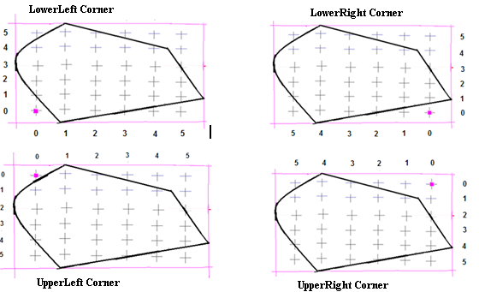
- StrMfgPinJigAdjustmentTypes – Need to be a combination of one value taken from each of the below classification:
      - Box Points – Possible values are :
  - “STRMFG_PinJig_Adjustment_BoxPoints_Contours” (Based on Contours) – Bounding box constructed based on the outer contours.
  - “STRMFG_PinJig_Adjustment_BoxPoints_Corners” (Based On Corners) – Bounding box constructed based on planes passing through the corners of the plates.
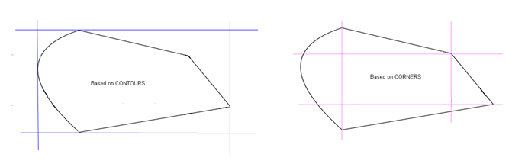
      - Offset Type – Possible values are :
  - “STRMFG_PinJig_Adjustment_Offset_Fixed” – First pin column/row maintains fixed offset distance from the origin.Last pin column/row maintains minimum overhang from the other edges.
  - “STRMFG_PinJig_Adjustment_Offset_Average” – Minimum offset distance is maintained on all sides. A best fit is done.
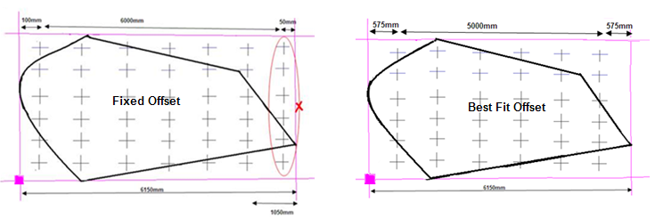

      - Extension Fill – This is applicable only for “Based on Corners” case. Possible values are :
  - “STRMFG_PinJig_Adjustment_Extension_Yes” –Additional columns/rows would be added to support geometry extensions.
  - “STRMFG_PinJig_Adjustment_Extension_No” – Additional columns/rows would not be added to support geometry extensions.
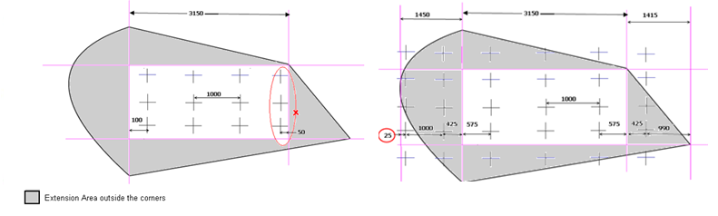
Eg: STRMFG_PinJig_Adjustment_BoxPoints_Corners Or STRMFG_PinJig_Adjustment_Offset_Fixed Or STRMFG_PinJig_Adjustment_Extension_Yes
STRMFG_PinJig_Adjustment_BoxPoints_Contours Or STRMFG_PinJig_Adjustment_Offset_Average
- SpecifyToleranceForPurpose
Signature: Private Function IJDPinJigAlignmentRule_SpecifyToleranceForPurpose(ByVal ToleranceContext As GSCADMfgRulesDefinitions.StrMfgPinJigToleranceTypes, ByVal lPinJigAlignmentType As Long, Optional ByVal ValForRounding As Double = 0#) As Double
Input: Tolerance context and the alignment type. “ValForRounding” is an optional input. This input contains the corresponding pin interval.
Output: This method returns the value for the input tolerance. It should be a ratio of the pin interval.
NOTE: If user wants to return the value as an absolute amount, then need to use “ValForRounding” input.
Description: This method returns the value for the input tolerance context and alignment type. Following are the various input tolerance contexts:
  - TransverseOffsetForOriginPin
  - LongitudinalOffsetForOriginPin
  - TransverseMinimumOverhang
  - LongitudinalMinimumOverhang
  - AddAdditionalRow
  - AddAdditionalColumn

The above tolerances would be used in the following order in “GetAdjustedPinBedPositions” method for adjustment of the corners:
- Offset would be applied on the Pinbed.
- Later, MinOverHang check would be done
- Later additonal row/col would be added

- Properties "TransverseOffsetForOriginPin" and "LongitudinalOffsetForOriginPin" are best explained by below figure:
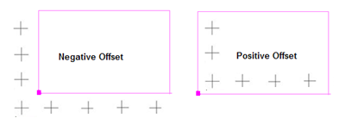

NEGATIVE Offset would move the pin origin outwards from the contours
POSITIVE Offset would move the pin origin inwards from the contours

These properties allow you to control these offsets along the transverse and longitudinal directions respectively. The values are fractions of their respective intervals.(i.e) between 0.0 and 1.0

- Properties "TransverseMinimumOverhang" and "LongitudinalMinimumOverhang" are best explained by below figure:
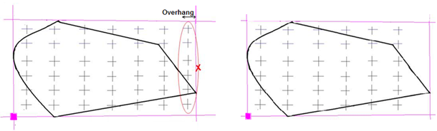

This enumerator specifies the minimum distance to be maintained between the pin row/column and the contour.
These values can be controlled along the transverse and longitudinal directions.The values returned are FRACTIONS of their respective intervals i.e., between 0.0 and 1.0
Sample Usage:
If you desire to have a row ONLY if the overhang exceeds half the longitudinal interval then return 0.5 for "LongitudinalMinimumOverhang".

E.g., if you desire to have a column ONLY if the overhang exceeds 100 mm (assume DBU is meters), then return (0.1 / ValForRounding) for "TransverseMinimumOverhang". (i.e) a minimum of 100mm overhang would be maintained in the transversal direction

NOTE: The input argument "ValForRounding" will contain the pin interval corresponding to "ToleranceContext". If ToleranceContext is "TransverseMinimumOverhang", ValForRounding will be Transverse Interval. If ToleranceContext is "LongitudinalMinimumOverhang", ValForRounding will be Longitudinal Interval.

- Properties "AddAdditionalRow" and "AddAdditionalColumn" indicate whether to add an additional row, column.
To always have an additional row or column (e.g., like a buffer zone), return ONE.
To never have an additional row or column, return ZERO
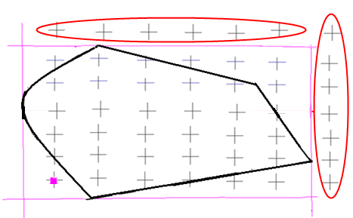
PINJIG BALANCE RULE:
The rule is delivered at “\SharedContent\Src\StructManufacturing\Rules\PinJig\ JigOrientation”.
“BalanceRule.cls” is the class file which has the default balance rule implementation.

- Balance rule would return the following:
  - Eligible balance options
  - Default balance option
  - Eligible inputs/criteria for user selection to define base plane
  - Base plane
- On clicking the base plane step, client calls the rule to get the eligible and default balance type.
- Once user selects the balance option, rule is invoked to compute the base plane(with system driven inputs).
- If the rule cannot compute the base plane for given balance type, client gets the eligible inputs from the rule and later calls the rule to get the base plane computed based on the user-selected inputs.

The following methods have been exposed on IJDPinJigBalanceRule interface:
- GetAllowablePinjigBalanceTypes
Signature: Private Function IJDPinJigBalanceRule_GetAllowablePinjigBalanceTypes(ByVal pPinJig As Object) As GSCADMfgRulesDefinitions.JCmnShp_CollectionAlias
Input: PinJig object
Output: Collection of allowable balance types
Description: This method takes the PinJig as input and returns the allowable balance types as a collection.
- GetDefaultBalanceType
Signature: Private Function IJDPinJigBalanceRule_GetDefaultBalanceType (ByVal pPinJig As Object) As Long
Input: PinJig object.
Output: Default balance type.
Description: This method takes the PinJig as input and returns the default balance type to be applied.
- GetEligiblePinJigBalanceInputs
Signature: Private Function IJDPinJigBalanceRule_GetEligiblePinJigBalanceInputs(ByVal pPinJig As Object, ByVal lActivePinJigBalance As Long) As GSCADPinJigEntity.JCmnShp_CollectionAlias
Input: PinJig object, balance type.
Ouput: Collection of eligible inputs required to compute the base plane.
Description: Based on the input balance type, this method proposes the eligible inputs/criteria for user selection to define the pin jig balance.
Below is the list of output collection for each balance type:
- AverageOfCorners – All the outer corners of the plates
- AverageOfLowerAftCornersPlane, AverageOfUpperAftCornersPlane, AverageOfLowerForeCornersPlane, AverageOfUpperForeCornersPlane - Extreme corners from the outer corners of the plates
- LowerAftCorners, UpperAftCorners, LowerForeCorners, UpperForeCorners – All the outer corners of the plates
- AverageOfFourPointsPlane, ByThreepointsPlane – All the outer corners of the plates and end points of entities such as seams, knuckles, reference curves, centerline, user-defined marking lines.
- AverageOfReferenceLineAndTwoCornersPlane, ReferenceLineAndOneCornerPlane - All the outer corners of the plates. Also, the entities such as seams, knuckles, reference curves, centerline, user-defined marking lines along with their end points.

Below is the overview of the methods on “IJMfgGeomUtil” that can be used to get the above inputs:
      - GetOuterCornersFromPlateCollection
- Inputs: Supported Plates
- Outputs:
- All the outer corners of the supported plates.
- All the outer contours of the supported plates.
      - GetExtremeCornersFromPlateCollection
        - Inputs: Supported Plates, Pin jig Balance Type
        - Outputs:
- Four corners of the supported plates.
        - If the Balance type is ‘AverageOfCornersPlane’, it returns the four extreme corners of the supported plates.
  - If the Balance type is ‘AverageOfLowerAftCornersPlane’, it returns the four corners of the supported plates. The first three will be the extreme corners representing the Pinjig Nature and the fourth corner will be the plate corner that is making the maximum angle with the first three corners. Similarly when the balance type is AverageOfUpperAftCornersPlane, AverageOfLowerForeCornersPlane, AverageOfUpperForeCornersPlane.
          - Multiple eligible corners of the supported plates.
            - If the Balance type is ‘AverageOfCornersPlane’, it returns the four extreme corners of the supported plates.
            - If the Balance type is ‘AverageOfLowerAftCornersPlane’, it returns multiple corners of the supported plates. The three corners will be the extreme corners representing the Pinjig Nature and the remaining corners will be the plate corners on the opposite side. Similarly when the balance type is AverageOfUpperAftCornersPlane, AverageOfLowerForeCornersPlane, AverageOfUpperForeCornersPlane.
      - GetEntitiesAndEndPoints
        - Inputs: Pinjig
          - Outputs:
          - Seams, Knuckles, Reference curves, User Defined Marking Lines of type ‘Pinjig Marking’
          - End points of Seams, Knuckles, Reference curves, Center Line, User Defined Marking Lines
- GetPinJigBasePlane
Signature: Private Function IJDPinJigBalanceRule_GetPinJigBasePlane(ByVal pPinJig As Object, ByVal lPinJigBalanceType As Long, ByVal lMinHeight As Double, ByVal pBalanceInputColl As GSCADMfgRulesDefinitions.JCmnShp_CollectionAlias, Optional pPointsColl As GSCADMfgRulesDefinitions.JCmnShp_CollectionAlias) As Object
Input: PinJig object, balance type, minimum height, user input collection(optional)
Output: Base plane and points collection used for computing the base plane(optional)
Description: This method returns the base plane for given balance type. If there are no user inputs, the method would return base plane computed with system driven inputs.
Below are the methods on ‘PinJigFloorUtils ‘ that can be used to get the base plane of supported plates:
- MostPlanarNaturalBalance
- TrueNaturalBalanceMethod
- AssemblyBalanceMethod
- ParallelAxisBalance
- PlateCornersBalance

NOTE:
- “PinJigBalanceHlpr.bas” is the module which holds the common functions.
- Public Sub GetEntitiesAndEndPoints(ByVal oPinJig As IJPinJig, ByRef oEntities As Collection, ByRef oEndPoints As Collection) is the function to be modified to control the reference objects used for base plane computation.

Future Considerations

